VS Code

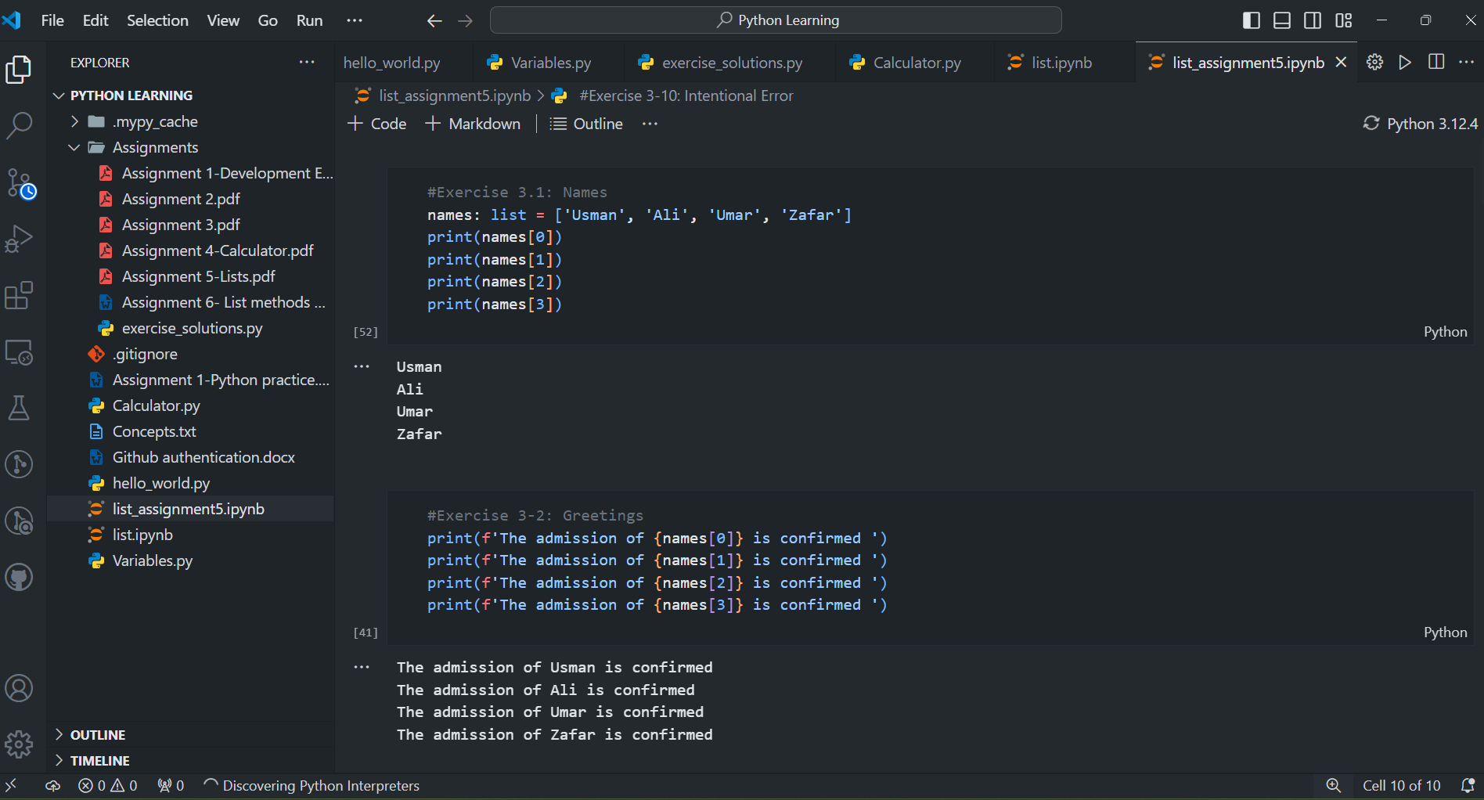

Python

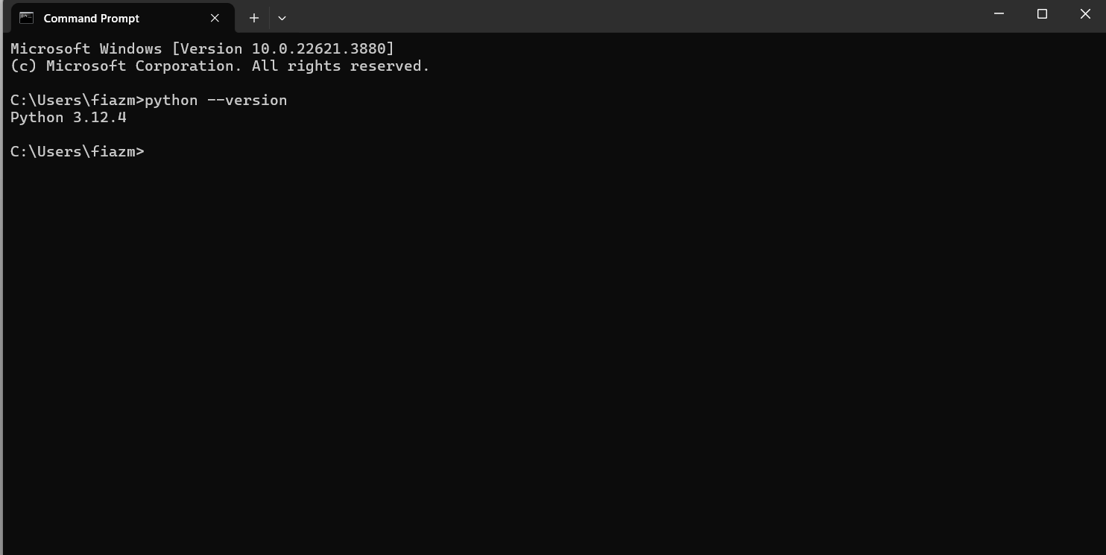

GitBash

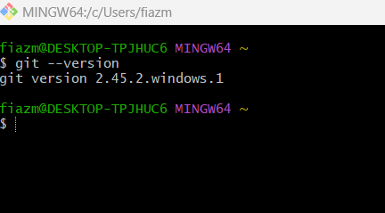

Github account

git config --list

diff.astextplain.textconv=astextplain

filter.lfs.clean=git-lfs clean -- %f

filter.lfs.smudge=git-lfs smudge -- %f

filter.lfs.process=git-lfs filter-process

filter.lfs.required=true

http.sslbackend=openssl

http.sslcainfo=C:/Program Files/Git/mingw64/etc/ssl/certs/ca-bundle.crt

core.autocrlf=true

core.fscache=true

core.symlinks=false

pull.rebase=false

credential.helper=manager

credential.https://dev.azure.com.usehttppath=true

init.defaultbranch=master

user.name=Fiaz Majeed

user.email=fiazcomsats@gmail.com

fiazm@DESKTOP-TPJHUC6 MINGW64 ~

$

VS Code Extensions

* Material Icon Theme

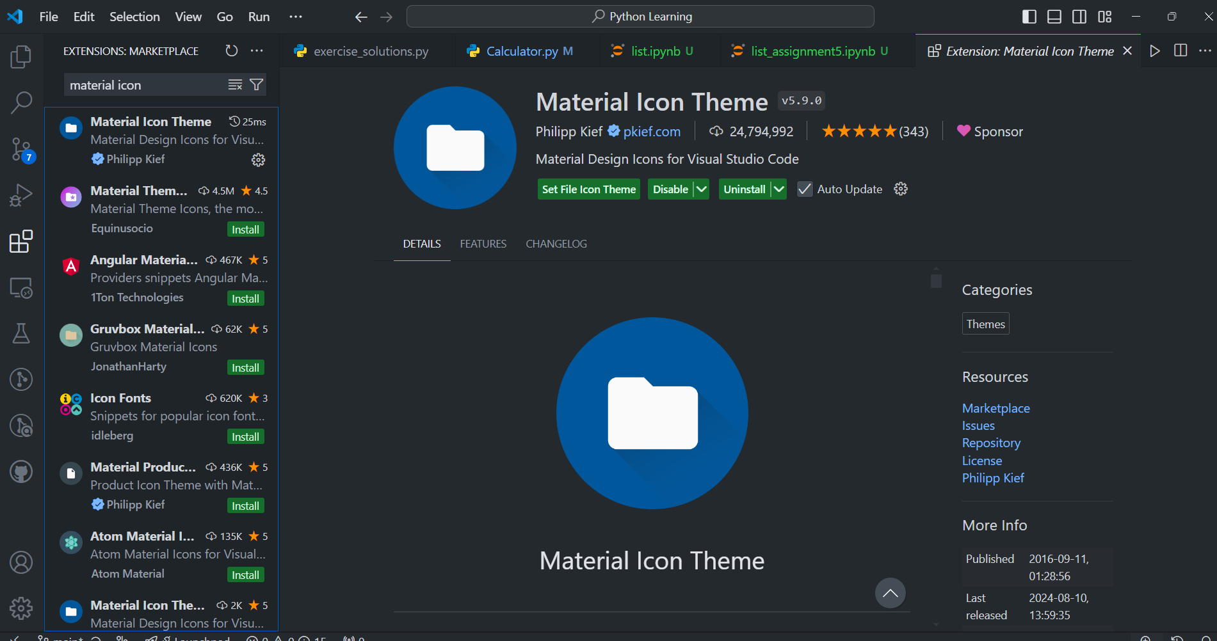

* GitLens – Git supercharged

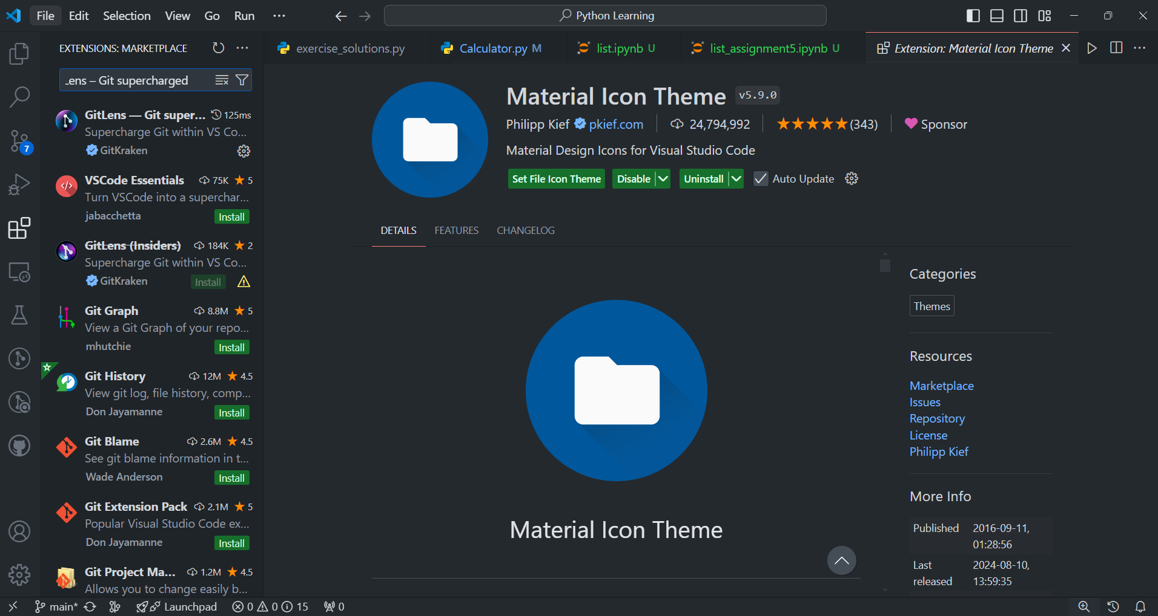

* Prettier – Code formatter

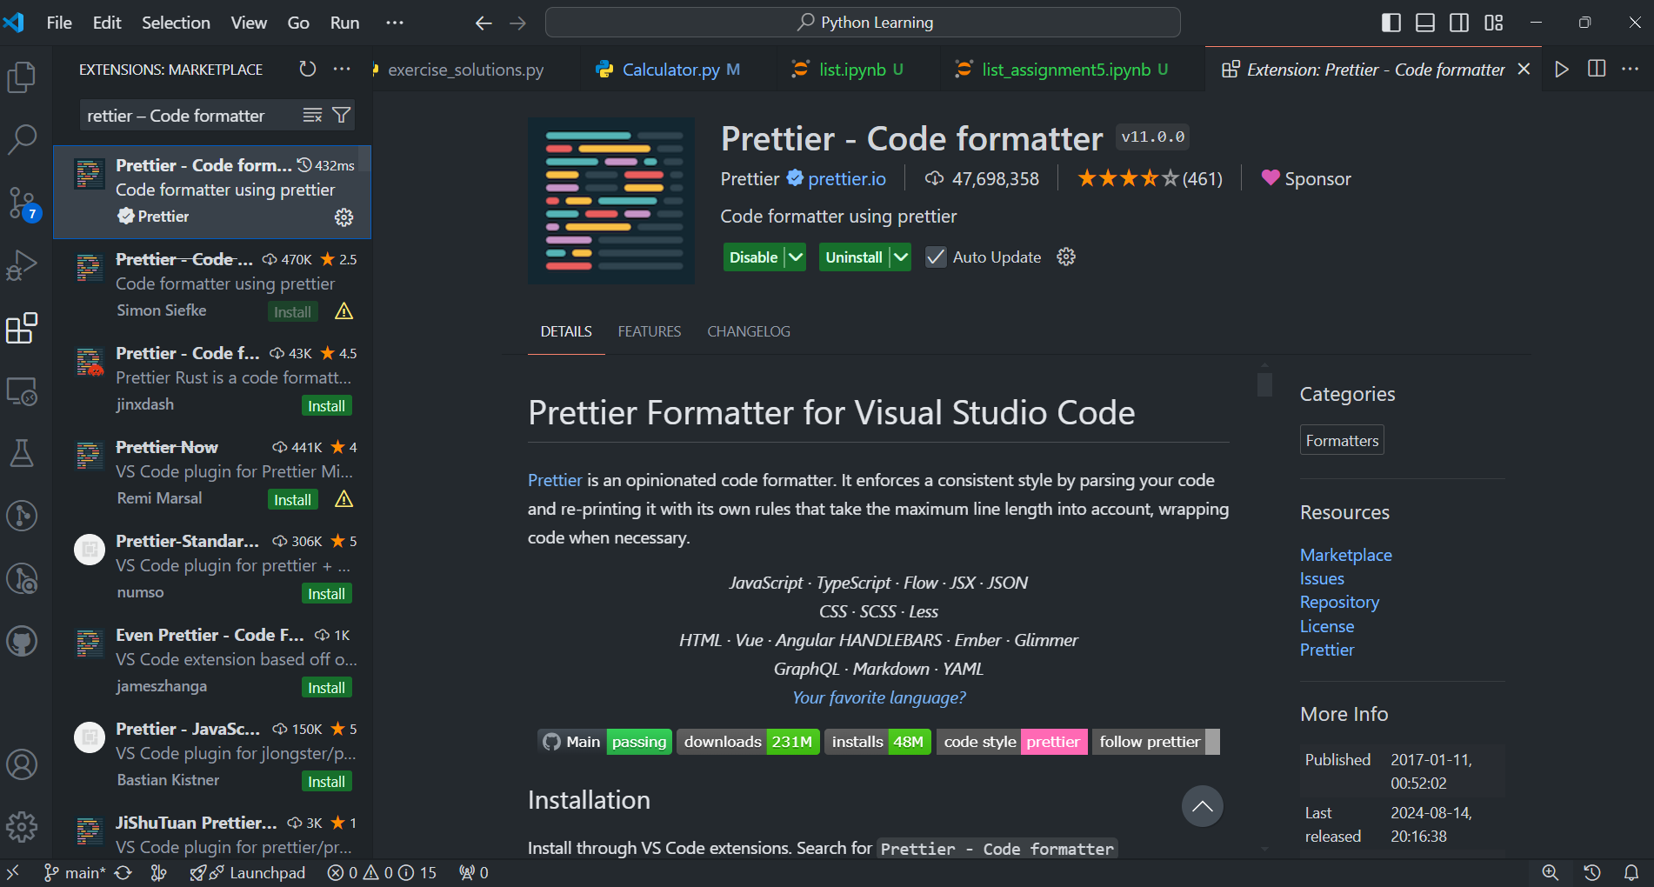

* Python

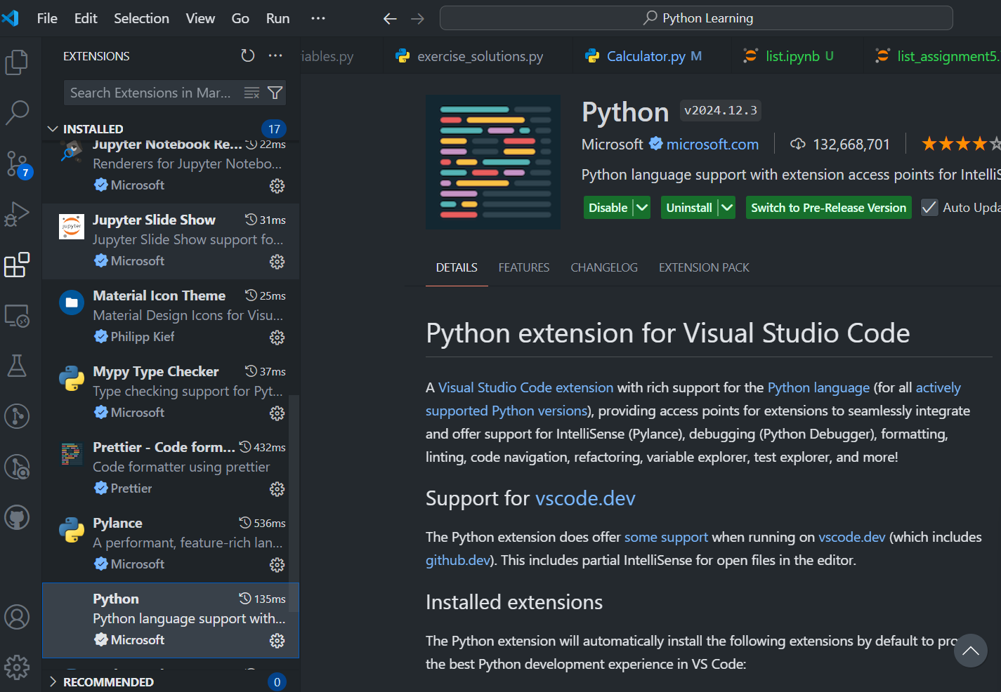

* Python debugger

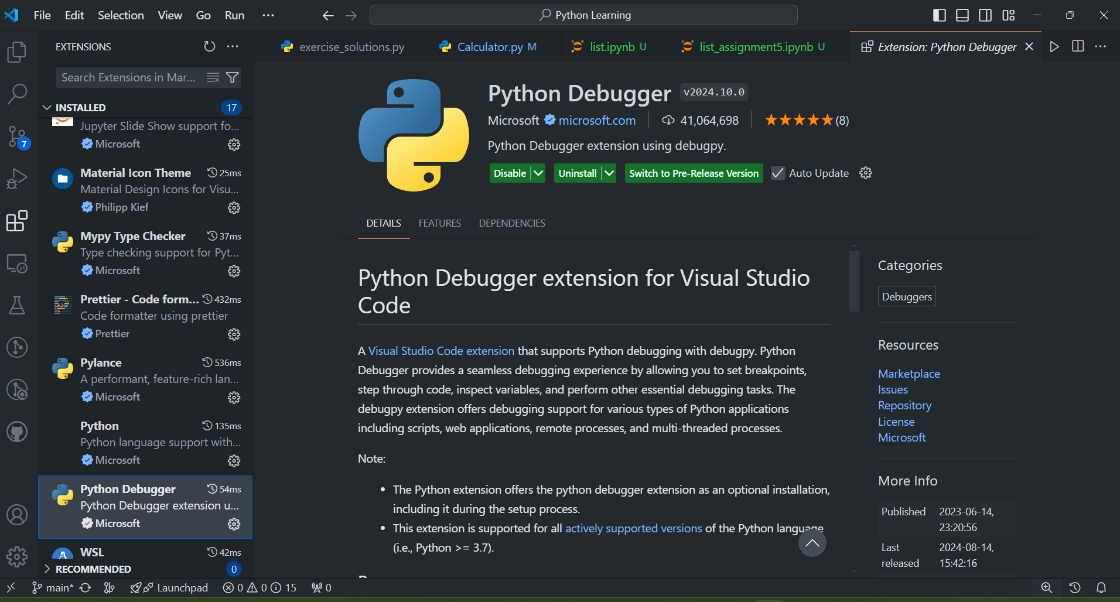

* Jupyter

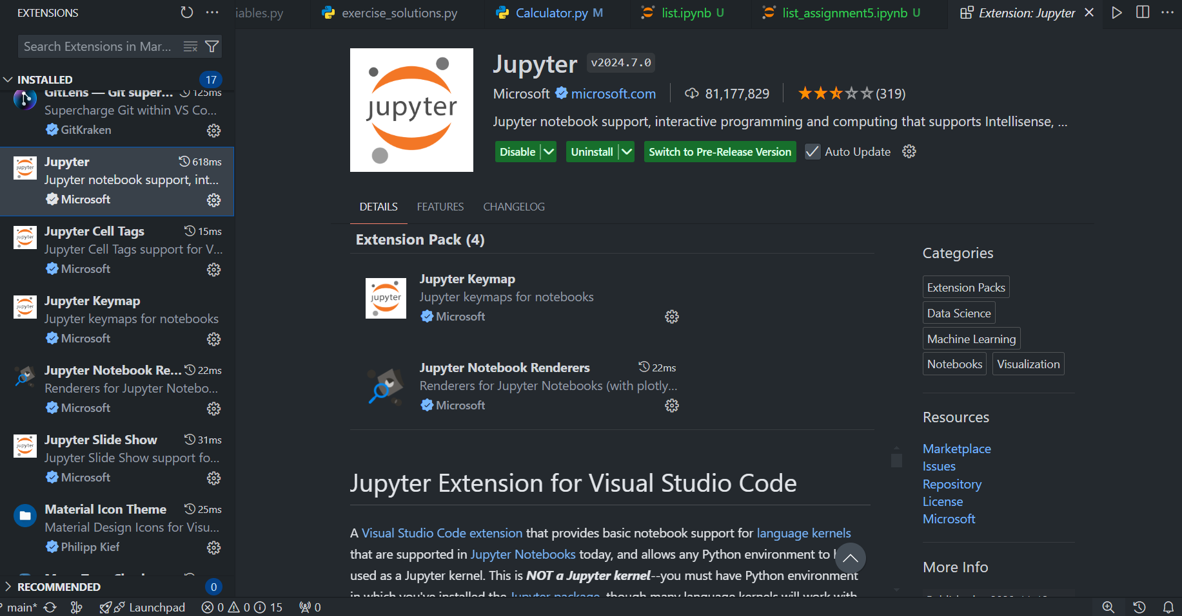

* Code Spell Checker

